Princess Sumaya University for Technology

King Abdullah II Faculty of Engineering

Electrical Engineering Department



**MICROPROCESSORS & EMBEDDED SYSTEMS**

**PROJECT – PET FEEDER MACHINE**

|  |
| --- |
|  |

|  |  |
| --- | --- |
| ***Authors:*** | ***Supervisor:*** |
| Zaina Wael 20180873  Abdulaziz abusaada 20190292  Medhat Aljaouni 20190412 | Dr. Belal Sabaha |

*June 5, 2023*

***Abstract***

*This paper presents the making of a pet feeding machine using the PIC16F877A microcontroller, in addition to a few different I/O components that include an LCD, servo-motor, RFID tags, ultra-sonic and an Arduino Uno. The general idea of this project revolves around allowing pet owners to automatically feed their pets without having to be physically present, it offers personalized tags for each pet which enables users to control the amount of food and meal times for every single pet individually, and thus food is dispensed accordingly. All electric design, programming and working mechanism details are to be thoroughly explained in this report.*

Table of Contents

Introduction 4

Background 4

Design 4

• Components: 4

• Mechanical Design 5

• Electric Design 6

Simulation: 6

• Software Design 7

Flow-Chart: 7

Working Mechanism 8

Problems and Recommendations 10

Conclusion 11

# Introduction

## Background

An automated device known as a pet feeder machine; feeds animals either on a predetermined schedule or in reaction to a trigger, such as a particular sound or activity. It is intended to make feeding pets more convenient for pet owners, particularly for those who lead hectic lives or who spend a lot of time away from home.

A pet feeder machine typically comprises of a food storage container, a feeding mechanism, and a sensor system or programmable timer that regulates the timing and amount of food supplied. The dispenser can be programmed to release a particular serving of food at predetermined intervals throughout the day or it can be manually activated by the pet or owner.

Machines for feeding pets can be connected into an electricity or run on batteries. Such devices might also offer extra capabilities, like a camera or microphone so that pet owners can check on their pets' eating habits from a distance or a voice recording so that the pet can be called over for meals. To sum up; a pet feeder machine offers pet owners a practical approach to make sure their animals are fed consistently and adequately, even when they are not present to do it.

The code for this project was written in C language in addition to some assembly lines where it was necessary, it is structured into different functions and utilizes interrupt-driven programming to efficiently handle tasks and so it demonstrates the implementation of an automated pet feeding system by utilizing various components such as an LCD display, ultrasonic sensor, PWM module and Timer1.

# Design

## Components:

Table : Components

|  |
| --- |
| PIC16F877A |
| Breadboard x2 |
| Potentiometer x1 |
| Buttons x3 |
| Wires |
| 8 MHz piezoelectric material crystal oscillator. |
| Resistors |
| 16x2 LCD |
| SG90 servo-motor |
| RFID |
| Ultra-Sonic |
| Arduino Uno |

## Mechanical Design

Our design consists of three sections, the upper base, food chamber and lower base, in addition to a measured bowl that indicates three different levels, and is made of blackboard material.

**The upper base** part of the design was made to hold the first breadboard of the device which includes the pic microcontroller, LCD, servo-motor and ultrasonic.

**The food chamber** part of the design which can be filled with food through a square backdoor secured with a lock comes right below and is sloped in such a way to dispense food directly into the bowl through a smaller door whose movement is controlled through the servo-motor attached to it.

**The measured bowl** in this design is square shaped and indicates three different levels with the ultrasonic installed above it on a piece of blackboard, which allows it to give us accurate readings.

**The lower base** part of the design, similar the upper base, was made to hold the second circuit of the machine which includes the RFID and Arduino Uno microcontroller.

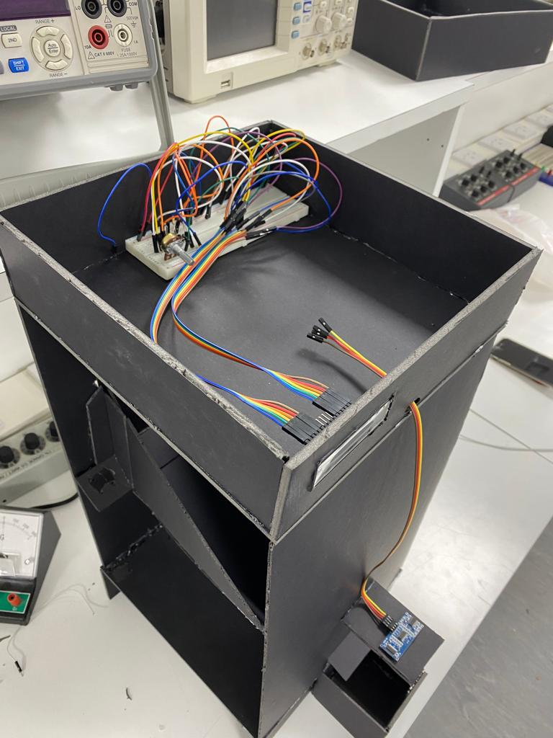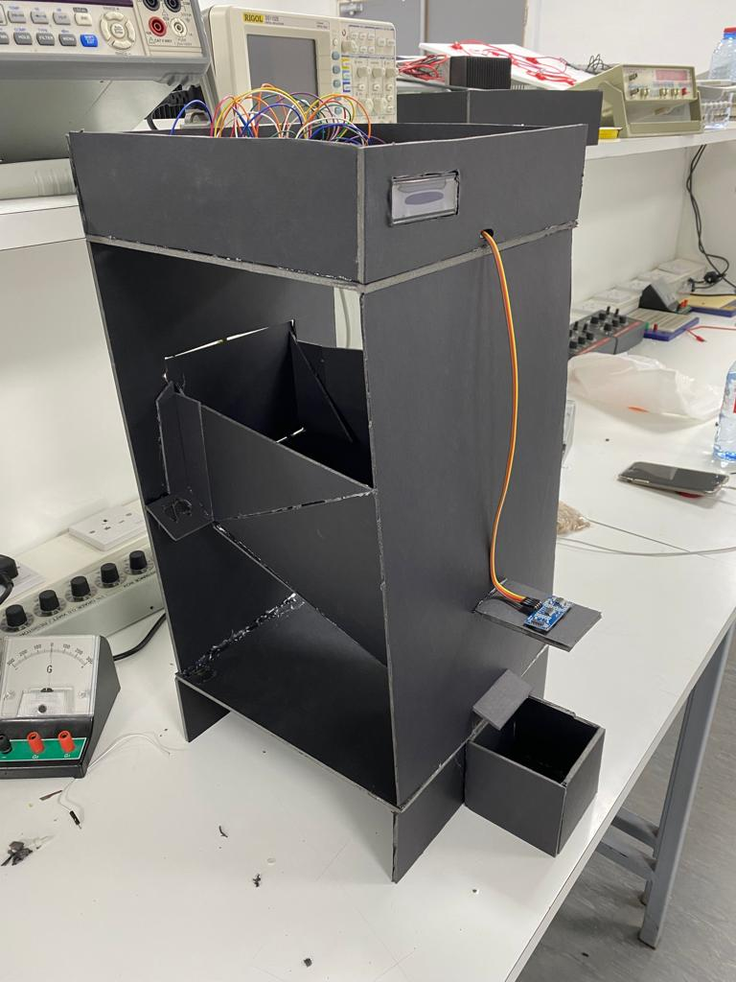

Figure 2: Upper Base

Figure 1: Food Chamber

## Electric Design

### Simulation:

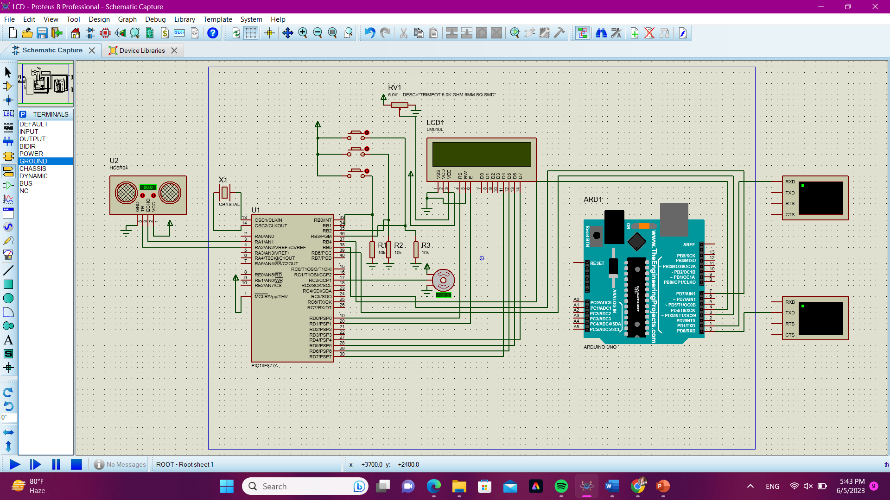

Figure 3: Electrical Design

## Software Design

### Flow-Chart:

### 

Figure 4: Software Design

# Working Mechanism

Our pet feeding machine operates by enabling users to set food levels and feeding times for their pets. It utilizes a servo-controlled feeding door and an ultrasonic sensor to ensure that the desired food level is reached before closing the door. The device's functionality is based on user inputs and continuous monitoring of time for accurate feeding schedules.

* Initialization:

The code starts off by initializing all necessary variables, pins and modules for the operation of our device, it then sets up the components mentioned in *table 1;* the LCD, ultrasonic sensor, PWM module to control the servo-motor and timer1 for timekeeping.

* User Setup:

The device first prompts the user to input the number of pets that are to be fed through the LCD and allows an answer to be given through the interfaced buttons which increment and decrement; to proceed with the setup an enter push-button is pressed to move on to the next stage.

* Pet Setup

For each pet, the level of food is selected and adjusted by the user through the LCD and buttons setup, the selected food level is then stored in an array called **“foodlevel”**

* Meal Timing Setup:

The device proceeds to prompt the user to set the time between meals for each pet in hours and minutes using the buttons, the entered values are stored in separate arrays: “**pettimeH”** for hours and “**pettimeM**” for minutes.

* Scan Mode:

Once the setup is complete; the pets’ RFID tags are scanned one by one so that each one is identified and fed according to the input information.

* Feeding Process:

When a particular pet (identified by its own RFID tag) is close by and scanned, the device checks if the current time matches its feeding time which was set beforehand, if they match and the level of food sensed by the ultrasonic is below the level set for this pet then the device dispenses food for it accordingly.

* Servo-motor Control:

If it is feeding time for the selected pet, the device opens the pet's feeding door by setting the servo position to 90 degrees, it then uses an ultrasonic sensor to measure the distance to the food level in centimeters. The servo position is gradually adjusted until the distance reaches or exceeds the set food level, once the condition is met, the servo is set back to the closed position (0 degrees), indicating the completion of the feeding process.

* Time Reset:

As soon as the feeding process is complete, the device resets the time variables for the selected pet to 0 which ensures that the feeding process will occur again at the next set time.

* Loop:

The device continues to loop, allowing the user to select and feed different pets based on their individual feeding schedules.

# Problems and Recommendations

* The first problem we encountered was regarding our initial idea for the food bowl which was to use a cell load sensor but we accidentally purchased a big scale sensor (0-5kgs) which seemed to be impractical considering the fact that pets’ food is to be measured in grams, and so we instead opted for an ultrasonic sensor and a measured bowl to instead measure distance to indicate the amount of food in the bowl.
* The second problem we faced had to do with the interfacing of the RFID card with the pic microcontroller which proved to be a little too complex and so that resulted in the inclusion of the Arduino Uno microcontroller which we then were able to interface with our pic.
* The third problem had to do with the angle at which our servo-motor was opening the door, and so after testing it on its own we realized that the servo-motor was not locking in place once given enough power supply and consequently had to be replaced.

# Conclusion

In conclusion, our pet feeding machine provides an efficient and practical solution for pet owners who cannot always be present since it automates the feeding by allowing users to set individualized feeding times and food levels for each pet, this device ensures that pets receive the appropriate amount of food at the designated times.

Our project offers several benefits to pet owners which include; maintaining a consistent feeding schedule, preventing missed meals or overfeeding. By automating the feeding process, users can ensure all their pets are fed accordingly.

The project can be extended and customized to accommodate the specific needs of different pets. The flexibility of the code allows for adjustments in the number of pets, food levels, and feeding times, making it adaptable to varying pet requirements.

Overall, the pet feeding device project represents a successful integration of hardware and software components to create an automated solution for pet feeding. It demonstrates the potential for technology to enhance the lives of both pets and their owners by providing convenience, accuracy, and peace of mind. With further development and refinement, this project has the potential to become a valuable tool for pet owners worldwide.